1. Design DFA using simulator to accept the string the end with ab over set {a,b)

W= aaabab

OUTPUT:-

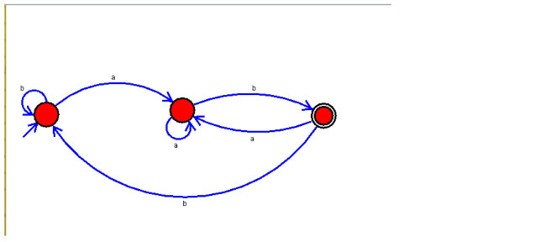

**RESULT**: THE DFA RUN SUCCESFULLY USING SIMULATOR BASED ON GIVEN STRINGS